**MULTILINEAR RIGRESSION**

**Business Problem** = ﻿﻿Prepare a prediction model sales Price of the computer.

* **Name of the File: -** Computer_Data.csv
* **Size of the File: -** 253 KB
* **Data: -** 6259 Observation, 10 Variable
* **Column Name: -** price, speed, hd, ram, screen, cd, multi, premium, ads ,trend

**Exploratory data Analysis** =

* **Outliers: -**  yes outliers are presents.
* **Missing Value: -** Data don’t have Missing Values
* **Normality: -** Data are not normal
* **Transformation: -**  May be Required to improve accuracy

**Scatter plot =** From below scatter plot we can say that there are not have any strong correlation

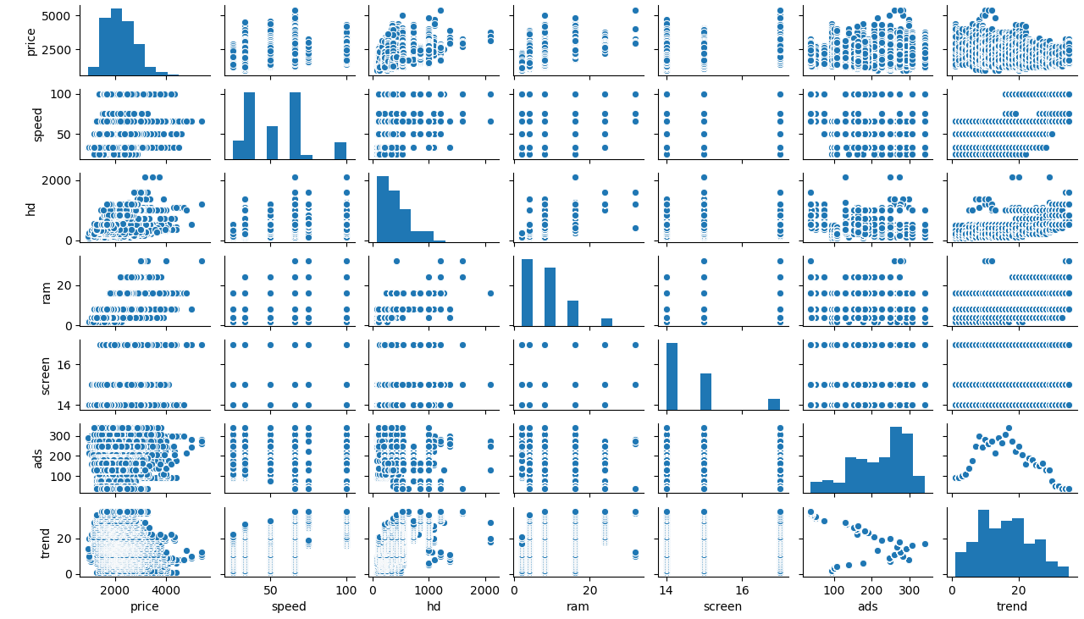

**Correlation Coefficient (r) =**  Correlation between price and ram is having moderate correlation and all other having weak correlation

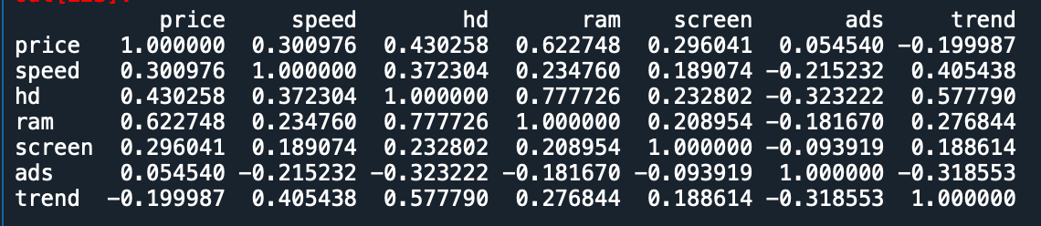

**Model 1 Building =**

* **Summary: -**

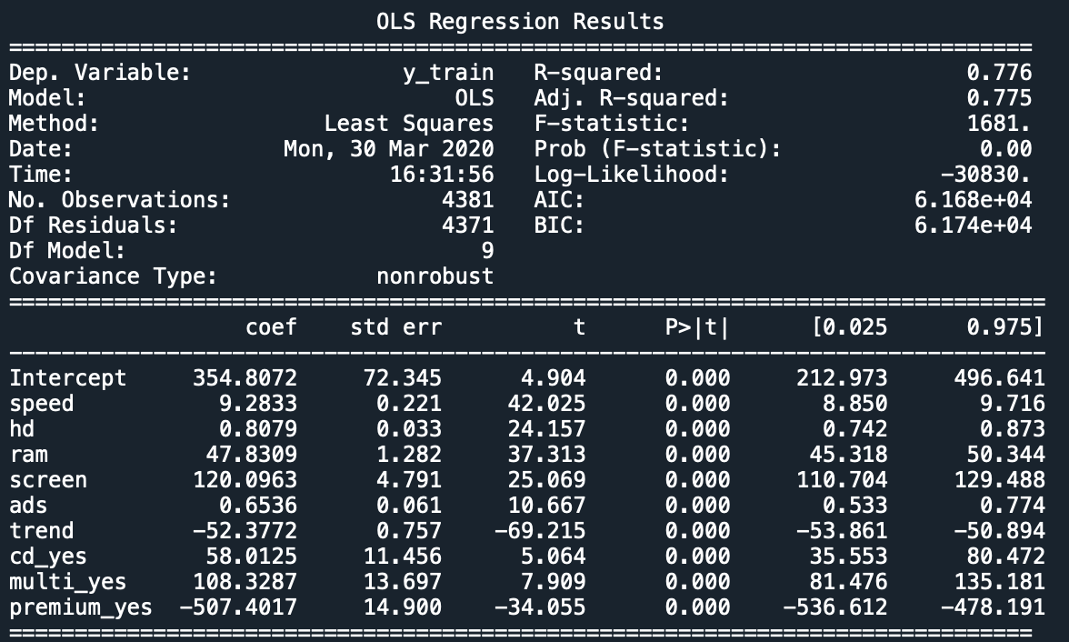

In above model R2 value is moderate, Adj. R2 is also moderate and all variable are significant

* **Intersect(B0): -** 354.80
* **Slope(B1): -** 9.28, 0.80, 47.83, 120.09, 0.65, -52.37, 58.01, 108.32, -507.40
* **Coefficient of**

**Determination (R2): -** 0.76 - Moderate Correlation

* **Pvalue: -** Pvalue less than 0.05, we can use intercept & slop for model building.
* **Model: - ﻿Price =**354.8+9.28(speed)+0.8(hd)+47.8(ram)+120(screen)+0.65(ads)-

52.4(trend)+58(cd)+108.32(multi)-507.4(premium)

* **RMSE:** - 275

**Model 2 Building =** Building model after considering transformation on each variable to increase R2

* **Summary: -**

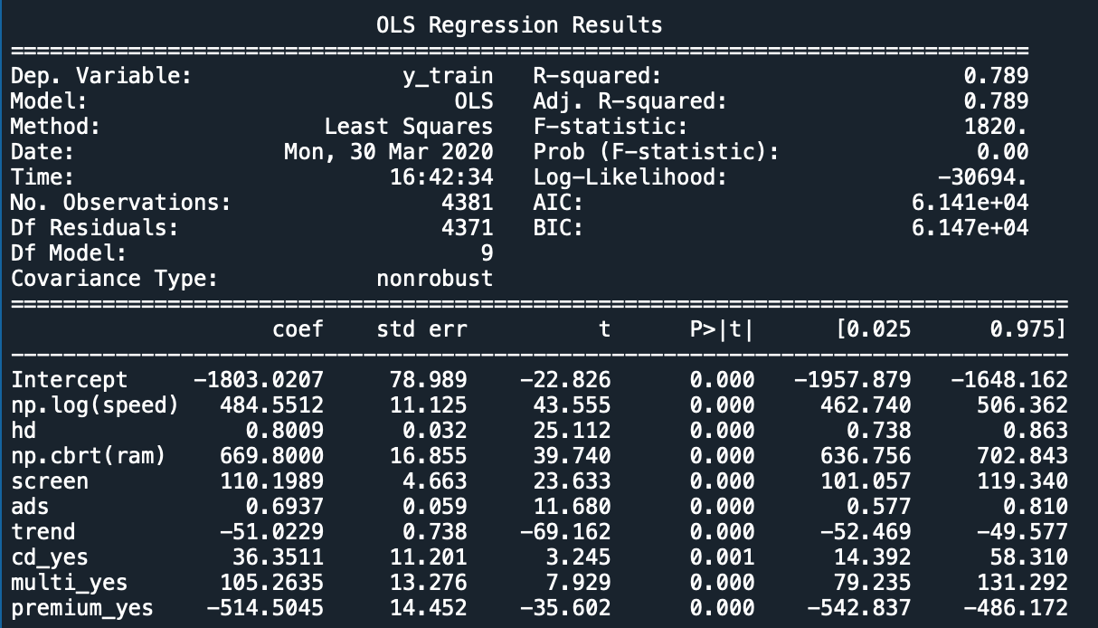

In above model R2 value is moderate, Adj. R2 is also moderate and all variable are significant

* **Intersect(B0): -** -1803
* **Slope(B1): -** 484.55, 0.80, 669.8, 110.2, 0.7, -51, 36.35, 105.3, -514.5
* **Coefficient of**

**Determination (R2): -** 0.79 - Moderate Correlation

* **Pvalue: -** Pvalue less than 0.05, we can use intercept & slop for model building.
* **Model: - ﻿Price =** -1803+484.55log(speed)+0.8(hd)+669.8(ram)+110.2(screen)+

0.7(ads)-51(trend)+36.35(cd)+105.26(multi)-514.5(premium)

* **RMSE:** - 266

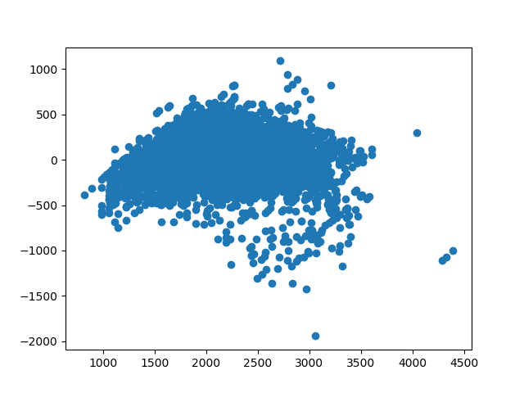**Residual Scatter Plot**: -

Error do not have any pattern. It means errors are independent and from below histogram we can say that errors are nearly normal distributed but having some outliers.

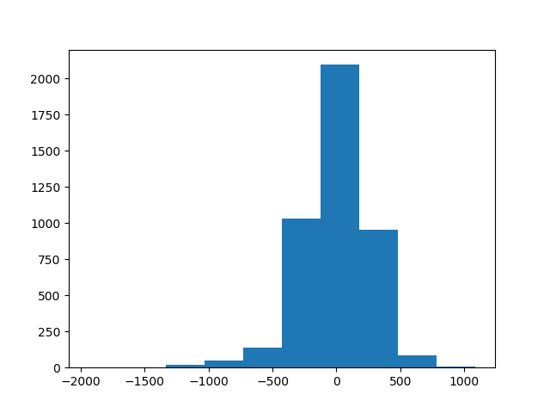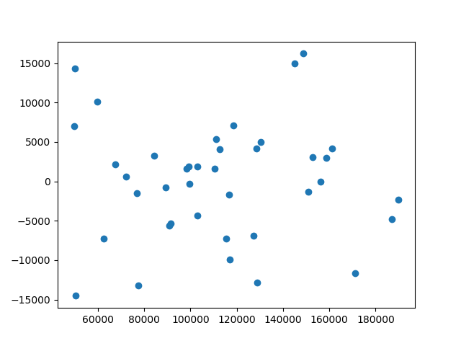

After considering all aspect we can say that model 2 is give us more accurate result as compare to other model.so we used model 2 as final model.

**Final Models with 95% confidence interval: -**

* **﻿** **﻿Price = -**1957.9+426.74log(speed)+0.73(hd)+636.75(ram)+101(screen)+0.6(ads)-

52(trend)+14.4(cd)+79.23(multi)-542.837(premium)

* **Price =** -1648,16+506.36log(speed)+0.863(hd)+702.84(ram)+119.34(screen)+0.81(ads)-

49.6(trend)+58.3(cd)+131.3(multi)-486.17(premium)

**Python code file**: - [Computer data Anslysis.py](https://github.com/nilaydeshmukh0/Multiple-Linear-Regression-With-EDA/blob/master/Computer%20data%20Anslysis/Computer%20data%20Anslysis.py)